Filing Procedures.docx
Include:

- Filing Period
- Filing Deadlines
Tax Season 2026 - All you need to know
https://www.iras.gov.sg/taxes/individual-income-tax/basics-of-individual-income-tax/understanding-my-income-tax-filing/tax-season-2026---all-you-need-to-know
y start filing your Income Tax between 1 Mar and 18 Apr 2026. This page outlines the steps and information required when filing.
Need help with e-filing? Visit go.gov.sg/efilingguide to view our step-by-step e-Filing guides.
On this page:Understanding what happens during tax season
Understanding what happens during tax season
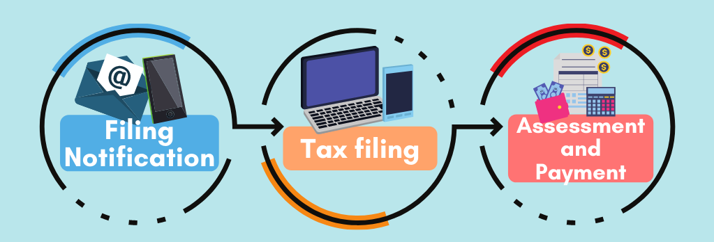
Filing notifications (SMS/Email/Letter) are sent between Feb and Mar. | If you received a notification to file, you may file from 1 Mar to 18 Apr. | Tax bills are issued progressively. To find out when you will receive yours, refer to Tax Season 2026 – About Your Tax bill.

- How to File Income Tax
- e-Filing your Income Tax Return
https://www.iras.gov.sg/taxes/individual-income-tax/basics-of-individual-income-tax/understanding-my-income-tax-filing/e-filing-your-income-tax-return
This page outlines the step-by-step instructions on e-Filing.
Advantages of e-Filing
- Filing taxes is easier
You may e-File at myTax Portal using your Singpass or Singpass Foreign user Account (SFA). An acknowledgement page will be shown after you have e-Filed successfully.
- 24/7 access to your account
Access your account anytime, anywhere!
Steps to e-File your Income Tax Return
Timeout
Please do not leave your filing session idle for more than 20 minutes. Otherwise, the session will expire and you will be required to log in to the portal again.
"Save as draft" option
If you are unable to complete your filing in one session, please save your Income Tax Return as a ‘draft’. The draft will be retained in the portal for 14 days. Please note that this draft is not a submission of your Income Tax Return. You are required to submit your Income Tax Return within 14 days of saving your draft or before 18 Apr, whichever is earlier.
You may access the draft and make the necessary amendments before you submit your Income Tax Return. To retrieve the draft copy of your Income Tax Return, log in to myTax Portal using your Singpass or Singapore Foreign user Account (SFA). On the top menu, click "Individuals" and select "File Income Tax Return". Follow the instructions shown on the screen to retrieve your Income Tax Return and continue to file.
Step 1: Get a Singpass or Singpass Foreign user Account (SFA)
Singpass is a digital ID that can be used to access all Government e-Services. You may apply for register for Singpass online and you should receive the One-Time Password PIN mailer within 3 - 10 working days. A 2-Step Verification (or 2FA) is required when you use Singpass. Find out more about Singpass.
If you are not eligible for Singpass, you may apply for a SFA online.
Step 2: Prepare the required documents
Before you log in to myTax Portal, make sure you have these documents ready:
- Singpass/SFA
- Form IR8A (if your employer is not participating in the Auto-Inclusion Scheme)
- Particulars of your dependants (e.g. child, parent) for new relief claims
- Details of rental income from your property (e.g. gross rent, expense claims) and other income, if any
- Business registration number/partnership tax reference number (for self-employed and partners only).
Step 3: Log in to myTax Portal
Log in to myTax Portal using your Singpass or Singapore Foreign user Account (SFA). Click on "Individuals" > "File Income Tax Return" to start. This electronic tax form may take about 5-10 minutes to complete. Please clear your cache (temporary internet files) before and after filing.
There are software requirements for accessing myTax Portal. Please refer to the operating systems and browsers that are supported.
Your session will expire if you leave it idle for more than 20 minutes. When this happens, you have to log in to the portal again.
Step 4: Verify your pre-filled income sources and personal reliefs in the income tax return
IRAS will pre-fill the following information in your income tax return:
- All income, deductions and reliefs information provided by the relevant organisations directly to IRAS. For example, employment income from employers participating in the Auto-Inclusion Scheme (AIS), donations, NSman Relief.
- Rental income based on your declaration in last year's Income Tax Return or e-stamped tenancy records.
- Reliefs allowed to you in the previous year (e.g. Qualifying Child Relief).
Verify that all the pre-filled information (i.e. income, deductions and reliefs) is accurate and complete. If the relevant organisations (e.g. your employers or approved charities) have transmitted the information to IRAS, please check with them directly for any discrepancy. The organisation will resubmit the information to us if there are errors in the original submission and this will be included in your tax assessment. In the meantime, please proceed to e-File your Income Tax Returns by 18 Apr each year.
Step 5: Declare other sources of income
If you have received any other sources of income which are not pre-filled (e.g. rental income), you need to declare the income in your Income Tax Return. Select "+ADD NEW" to open details page and enter your income in the boxes provided to declare your additional income. After filling the details, select "UPDATE" to save the details into the main form.
If your employer is participating in the Auto-Inclusion Scheme (AIS) for Employment Income but details are not shown under the “Employment Income and Expenses” section in the Income Tax Return, tick the “My employer(s) will transmit my income details to IRAS; I do not need to report them myself” option:
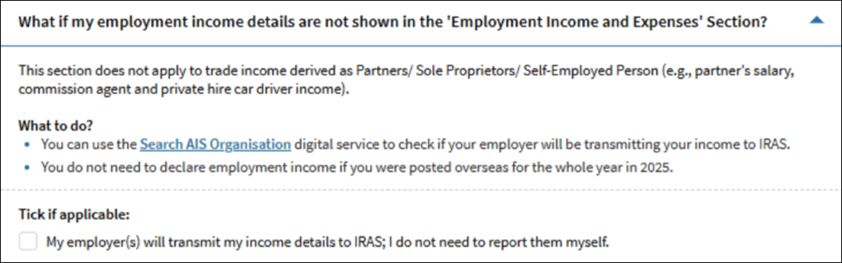
What if my employment income details are not shown above?
- If you are unsure whether your employer(s) will be transmitting your employment income details to IRAS, you may use Search AIS Organisation to check.
- If you were posted to work overseas for the whole year in 2025, you are not required to declare your employment income details.
Step 6: Update existing tax reliefs
Enter your deductions/reliefs in the boxes provided or click on the relevant hyperlinks to:
- Remove the pre-filled reliefs which you no longer qualify
- Change/amend the amount of reliefs which are shared with other claimants
- Make new claims for deductions/reliefs.
Find out more from the Quick Guide for e-Filers (PDF, 570KB).
Filing Tip: During filing, you will be presented with a question: "My spouse/child/parent/caregiver did not have an annual income of more than $8,000 in 2025". If your dependant did not have an annual income of more than $8,000 in 2025, please select the "Yes" checkbox.
Step 7: View Consolidated Statement
A Consolidated Statement will be displayed and fields that are manually updated are shown as '(Updated)'.
Check the declaration box and select "Submit" to proceed with the submission of your tax return.
Step 8: Receive an acknowledgement receipt
An acknowledgement page will be shown after you have e-Filed successfully. You are advised to save a copy or print the page for future reference.
Re-filing before receipt of your tax bill (i.e. Notice of Assessment)
You may only re-file once. Re-filing must be done by 18 Apr.
When you re-file, you must include all your income details (excluding information provided by employers participating in the Auto-Inclusion Scheme (AIS) for Employment Income and other relevant organisations) and expenses/donations/reliefs claims. Once you have re-filed successfully, your new submission will override the previous submission.
If you are unable to re-file by 18 Apr, please file an amendment upon receiving your Tax Bill for the current Year of Assessment. You may file the amendment via the 'Amend Tax Bill' digital service at myTax Portal within 30 days from the date of your tax bill.
Update Contact & Notification Preferences
Most IRAS notices are digitised. Stay informed by updating your contact details or notification preferences via the ' Update Contact & Notification Preferences' digital service at myTax Portal using your Singpass or Singapore Foreign user Account (SFA) to receive timely notifications when your notices are ready for viewing.

E-Filling
e-Filing your Income Tax Return
https://www.iras.gov.sg/taxes/individual-income-tax/basics-of-individual-income-tax/understanding-my-income-tax-filing/e-filing-your-income-tax-return
Share:
This page outlines the step-by-step instructions on e-Filing.
On this page:Related Content
Advantages of e-Filing
- Filing taxes is easier
You may e-File at myTax Portal using your Singpass or Singpass Foreign user Account (SFA). An acknowledgement page will be shown after you have e-Filed successfully.
- 24/7 access to your account
Access your account anytime, anywhere!
Steps to e-File your Income Tax Return
Timeout
Please do not leave your filing session idle for more than 20 minutes. Otherwise, the session will expire and you will be required to log in to the portal again.
"Save as draft" option
If you are unable to complete your filing in one session, please save your Income Tax Return as a ‘draft’. The draft will be retained in the portal for 14 days. Please note that this draft is not a submission of your Income Tax Return. You are required to submit your Income Tax Return within 14 days of saving your draft or before 18 Apr, whichever is earlier.
You may access the draft and make the necessary amendments before you submit your Income Tax Return. To retrieve the draft copy of your Income Tax Return, log in to myTax Portal using your Singpass or Singapore Foreign user Account (SFA). On the top menu, click "Individuals" and select "File Income Tax Return". Follow the instructions shown on the screen to retrieve your Income Tax Return and continue to file.
Step 1: Get a Singpass or Singpass Foreign user Account (SFA)
Singpass is a digital ID that can be used to access all Government e-Services. You may apply for register for Singpass online and you should receive the One-Time Password PIN mailer within 3 - 10 working days. A 2-Step Verification (or 2FA) is required when you use Singpass. Find out more about Singpass.
If you are not eligible for Singpass, you may apply for a SFA online.
Step 2: Prepare the required documents
Before you log in to myTax Portal, make sure you have these documents ready:
- Singpass/SFA
- Form IR8A (if your employer is not participating in the Auto-Inclusion Scheme)
- Particulars of your dependants (e.g. child, parent) for new relief claims
- Details of rental income from your property (e.g. gross rent, expense claims) and other income, if any
- Business registration number/partnership tax reference number (for self-employed and partners only).
Step 3: Log in to myTax Portal
Log in to myTax Portal using your Singpass or Singapore Foreign user Account (SFA). Click on "Individuals" > "File Income Tax Return" to start. This electronic tax form may take about 5-10 minutes to complete. Please clear your cache (temporary internet files) before and after filing.
There are software requirements for accessing myTax Portal. Please refer to the operating systems and browsers that are supported.
Your session will expire if you leave it idle for more than 20 minutes. When this happens, you have to log in to the portal again.
Step 4: Verify your pre-filled income sources and personal reliefs in the income tax return
IRAS will pre-fill the following information in your income tax return:
- All income, deductions and reliefs information provided by the relevant organisations directly to IRAS. For example, employment income from employers participating in the Auto-Inclusion Scheme (AIS), donations, NSman Relief.
- Rental income based on your declaration in last year's Income Tax Return or e-stamped tenancy records.
- Reliefs allowed to you in the previous year (e.g. Qualifying Child Relief).
Verify that all the pre-filled information (i.e. income, deductions and reliefs) is accurate and complete. If the relevant organisations (e.g. your employers or approved charities) have transmitted the information to IRAS, please check with them directly for any discrepancy. The organisation will resubmit the information to us if there are errors in the original submission and this will be included in your tax assessment. In the meantime, please proceed to e-File your Income Tax Returns by 18 Apr each year.
Step 5: Declare other sources of income
If you have received any other sources of income which are not pre-filled (e.g. rental income), you need to declare the income in your Income Tax Return. Select "+ADD NEW" to open details page and enter your income in the boxes provided to declare your additional income. After filling the details, select "UPDATE" to save the details into the main form.
If your employer is participating in the Auto-Inclusion Scheme (AIS) for Employment Income but details are not shown under the “Employment Income and Expenses” section in the Income Tax Return, tick the “My employer(s) will transmit my income details to IRAS; I do not need to report them myself” option:

What if my employment income details are not shown above?
- If you are unsure whether your employer(s) will be transmitting your employment income details to IRAS, you may use Search AIS Organisation to check.
- If you were posted to work overseas for the whole year in 2025, you are not required to declare your employment income details.
Step 6: Update existing tax reliefs
Enter your deductions/reliefs in the boxes provided or click on the relevant hyperlinks to:
- Remove the pre-filled reliefs which you no longer qualify
- Change/amend the amount of reliefs which are shared with other claimants
- Make new claims for deductions/reliefs.
Find out more from the Quick Guide for e-Filers (PDF, 570KB).
Filing Tip: During filing, you will be presented with a question: "My spouse/child/parent/caregiver did not have an annual income of more than $8,000 in 2025". If your dependant did not have an annual income of more than $8,000 in 2025, please select the "Yes" checkbox.
Step 7: View Consolidated Statement
A Consolidated Statement will be displayed and fields that are manually updated are shown as '(Updated)'.
Check the declaration box and select "Submit" to proceed with the submission of your tax return.
Step 8: Receive an acknowledgement receipt
An acknowledgement page will be shown after you have e-Filed successfully. You are advised to save a copy or print the page for future reference.
Re-filing before receipt of your tax bill (i.e. Notice of Assessment)
You may only re-file once. Re-filing must be done by 18 Apr.
When you re-file, you must include all your income details (excluding information provided by employers participating in the Auto-Inclusion Scheme (AIS) for Employment Income and other relevant organisations) and expenses/donations/reliefs claims. Once you have re-filed successfully, your new submission will override the previous submission.
If you are unable to re-file by 18 Apr, please file an amendment upon receiving your Tax Bill for the current Year of Assessment. You may file the amendment via the 'Amend Tax Bill' digital service at myTax Portal within 30 days from the date of your tax bill.
Update Contact & Notification Preferences
Most IRAS notices are digitised. Stay informed by updating your contact details or notification preferences via the ' Update Contact & Notification Preferences' digital service at myTax Portal using your Singpass or Singapore Foreign user Account (SFA) to receive timely notifications when your notices are ready for viewing.
Related Content

- Paper File
Filing a paper Income Tax Return
https://www.iras.gov.sg/taxes/individual-income-tax/basics-of-individual-income-tax/understanding-my-income-tax-filing/filing-a-paper-income-tax-return
More than 98% of individual taxpayers e-File their Income Tax Returns. However, if you are unable to e-File and wish to file a paper Return instead, you will receive the relevant tax form from IRAS in Mar each year.
Receiving a paper Income Tax Return
If you are on paper filing and required to file an Income Tax Return, the relevant paper form will be sent to you from Mar. Please submit your paper Tax Return by 18 Apr.
For a more convenient and seamless filing experience, we encourage you to e-File at myTax Portal using your Singpass or Singpass Foreign user Account (SFA). If you e-File, your income and relief information will be prefilled in your online form for subsequent years, reducing the hassle of filling up your information every year. You will also receive an instant acknowledgement of your tax submission.
If you are certain that you have to file, but did not receive a notification from us by Mar, you may check your notification at myTax Portal using your Singpass or Singpass Foreign user Account (SFA).
When filing your Income Tax Return, you do not need to declare the employment income received from your employer who is participating in the Auto-Inclusion Scheme (AIS). This information would be automatically included in your income tax assessment.
If your employer is under the AIS, please enter "0" for your employment income and any donations, CPF contributions and life insurance premium deducted from your salary.Collapse all

Income Tax Return for tax resident individuals

Tax resident individuals should receive:
- Form B1 2026
- Appendices 1 and 2
- Return envelope

Income Tax Return for self-employed individuals

Self-employed individuals should receive:
- Form B 2026
- Appendices 1 and 2
- Return envelope
For more details on filing, please refer Basic guide for self-employed persons.

Income Tax Return for non-resident individuals

Non-resident individuals should receive:
- Form M 2026
- Appendix
- Return envelope
For more information on filing, please refer to Tax Season 2026 - All you need to know.
Please sign on page 1 of the paper Income Tax Return and send it to us using the return envelope provided by 18 Apr.
Documents not required for submission
You are not required to submit the following documents unless requested:
- Form IR8A (Electronic)/NSmen reservist pay
- Vouchers/Statements for auto-included dividends (e.g. NTUC Fairprice dividend vouchers)
- All receipts (e.g. receipts for rental expenses, donations, subscriptions, course fees, insurance and entertainment)
- Foreign domestic worker levy statements

- Required Documents
https://www.iras.gov.sg/taxes/individual-income-tax/self-employed-and-partnerships/keeping-proper-records-and-accounts
Keeping proper records and accounts
Share:
Self-employed persons including sole-proprietors and partners are required to keep proper records and accounts of business transactions.
On this page:FAQs
Requirement to keep proper records and accounts
You should keep proper records and accounts for 5 years so that the income earned and business expenses claimed can be readily determined. You must be able to support your records and accounts with invoices, receipts, vouchers and other supporting documents.
Estimates and improper records are not acceptable.
Records to verify income and claims for deduction
Sales/ Income
Records include cash register tape, daily sales record book and invoices.
Expenses/ Claims
Receipts and daily purchases record book.
You are not required to submit these records unless requested by IRAS. Upon request by IRAS, you may be required to substantiate your reported income and expense claims with records and accounts.
Producing data listings of your business accounts in Microsoft Excel spreadsheet format will help expedite any audit review by IRAS. If you are using accounting software or have engaged a book-keeper for your business, please extract or request for a copy of your business accounts and general ledgers in Microsoft Excel spreadsheet format.
The term 'accounts' refer to the trading and profit and loss accounts as well as the balance sheets.
Requirement to issue receipts
You may issue simplified tax invoices if the total amount payable for your supply (including GST) does not exceed $1,000. Please refer to Invoicing customers.
If you are not GST-registered, you may issue receipts which act as proof of your sales made to customers. Receipts must be serially numbered with duplicate copies retained.
You do not need to issue receipts if you adopt practices that can ensure the completeness and accuracy of the recording of all your sales receipts. However, a receipt must still be issued upon your customer's request.
Duration for records and accounts keeping
You are required to retain the accounting records and supporting documents for 5 years.
Failure to do so may result in:
- Expenses claimed being disallowed; or/ and
- Additional income assessed by IRAS based on best estimate; and/ or
- Penalties
Examples:
Businesses with December financial year end
YA  2021 | Records for period  1 Jan 2020 to 31 Dec 2020 | To keep up to  31 Dec 2025
YA  2024 | Records for period  1 Jan 2023 to 31 Dec 2023 | To keep up to  31 Dec 2028
Businesses with non-December financial year end, e.g. June, September
YA  2021 | Records for period  1 Jul 2019 to 30 Jun 2020 | To keep up to  31 Dec 2025
YA  2024 | Records for period  1 Oct 2022 to 30 Sep 2023 | To keep up to  31 Dec 2028
Where a Limited Liability Partnership (LLP) has been struck off and dissolved, the partners of the LLP immediately before the LLP was dissolved must ensure that all books and papers of the LLP are retained for 5 years after the dissolution of the LLP.
Where an LLP is being wound up, the liquidator of the LLP must ensure that all the books and papers of the LLP are retained for 5 years from the date of dissolution of the LLP.
Financial accounts in other currencies
If you maintain your financial accounts in a currency other than the Singapore dollar, you should also file your tax computations and financial statements to the Comptroller in that currency.
However, in the Income Tax Return, you must declare the equivalent Singapore dollar amount. Please refer to the IRAS Circular on Filing of Income Tax Computations in Functional Currencies other than Singapore Dollars (PDF, 408KB)

Guides on record keeping
GST-registered businesses
For GST-registered businesses, please refer to the Record Keeping Guide for GST-Registered Businesses (PDF, 310KB) for the record keeping requirements for both Income Tax and GST purposes. The guide also covers requirements for keeping business records in electronic media and imaging systems.
Non GST-registered businesses
For non GST-registered businesses, please refer to the Record Keeping Guide for Non GST-Registered Businesses (PDF, 264KB) for the record keeping requirements for Income Tax purposes. The guide also covers requirements for keeping business records in electronic media and imaging systems.
Non GST-registered small businesses
IRAS recognises that small businesses have simpler business and tax matters. Small businesses that meet the qualifying conditions can adopt the Simplified Record Keeping Requirements for Small Businesses (PDF, 492KB).
Please refer to the Record Keeping Checklist (PDF, 61KB), which provides a summary of the different types of records required.
If your business’ annual revenue is $500,000 or below, and you are not claiming carry-back relief, foreign tax credit, or tax deducted at source, download our Record Keeping Assistant (XLSX, 549KB) to help you to keep and organise your business records for tax preparation.
DOWNLOAD RECORD KEEPING ASSISTANT
Record keeping self-assessment toolkit
IRAS has created a self-assessment toolkit to help businesses perform a self-review of their existing record keeping standards and to better understand the possible areas for improvement.
For Non GST-registered businesses, please download the toolkit (XLSX, 30KB).
For GST-registered businesses, please download the toolkit (XLSX, 172KB).
FAQs

If my business purchases a new accounting software, do I need to migrate all the accounting transactions recorded in the existing accounting software to the new accounting software?

- Keeping records
Types of records to keep
https://www.iras.gov.sg/taxes/goods-services-tax-(gst)/basics-of-gst/invoicing-price-display-and-record-keeping/keeping-records
GST-registered businesses must keep proper business and accounting records for at least 5 years to support GST declarations.
Income records
- Tax invoices/simplified tax invoices issued, serially numbered receipts issued or cash register tapes to explain each sales transaction
- Rental agreements signed by both landlord and tenant to explain your rental income
- Credit notes for returned goods
- Documents relating to your exports (e.g. bill of lading, air waybill, export permit)
- Evidence that you have received payment (e.g. bank statement)
Purchase & business expense records
- Invoices or receipts received to explain each purchase transaction or business expense
- Documents relating to your imports (e.g. bill of lading, air waybill, import permit)
- Payment vouchers on payment made to individuals/companies for services rendered and the relevant contracts/agreements on the provision of services
- Rental agreements signed by both landlord and tenant to explain your rental expenses
- Evidence that you have made payment for the purchases (e.g. bank statement)
Other records to support GST declarations
1. You must also keep the source documents of all other business transactions that affect the output tax and input tax reported in your GST return.
Some of these transactions include:
- Use of business assets for private purpose
- Disposal of business assets
- Removal of goods from customs-licensed warehouse
2. Records of the steps taken to ascertain whether the supply made to you or by you was part of a Missing Trader Fraud arrangement.
- The risks assessed
- The due diligence checks performed, including any checks designed to address the specific risks
- The actions taken in response to the results from the checks
Statements & accounting schedules
To keep track of and summarise your records, you should also keep:
- Bank statements of your business (separate bank accounts for personal and business purposes is recommended)
- Stock lists to explain your trading stock on hand at the end of each accounting period
- General ledgers to record your assets and liabilities, revenue and expenses
- Statement of accounts such as Balance sheet and Profit and Loss Statements
- Sale listings in the format below to explain your supplies 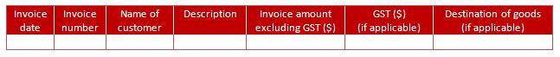
- Purchase listings in the format below to explain your purchases
- Use these templates (XLSX, 66KB) to prepare your sale and purchase listings.
For more details, please refer to our Record Keeping Guide for GST-registered Businesses (PDF, 311KB).
All business and accounting records are maintained for at least 5 years. Failure to do so may result in input GST claims being disallowed and/ or penalties.
---
- GST
GST account
A GST account is a summary of the totals of your input tax and output tax for each accounting period. You may wish to keep a GST account to facilitate your completion of the GST returns.
Electronic records
You do not need to seek approval from the Comptroller of GST to keep your records in other forms (e.g. electronic media and imaging systems), so long as you satisfy the requirements in the guides below.
Learn more about the various requirements:
GST-registered businesses
Please refer to Record Keeping Guide for GST-registered Businesses (PDF, 311KB) for the record keeping requirements. The guide also covers requirements for keeping business records in electronic media and imaging systems.
Non-GST registered businesses
Please refer to Record Keeping Guide for Non-GST registered Businesses (PDF, 334KB) for the record keeping requirements. The guide also covers requirements for keeping business records in electronic media and imaging systems.
Non-GST registered small businesses adopting simplified record keeping requirements
For non-GST registered small businesses that satisfy the qualifying conditions to adopt simplified record keeping requirements from 1 Jan 2014 for Year of Assessment (YA) 2015, please refer to the Simplified Record Keeping Requirements for Small Businesses (PDF, 457KB).
For a summary of the different types of records required, refer to the Record Keeping Checklist (PDF, 64KB).
Record keeping self-assessment toolkit
Use our self-assessment toolkit to perform a self-review of your existing record keeping standards and to better understand the possible areas for improvement.
For GST-registered businesses, please download the toolkit (XLSX, 172KB).
For Non-GST registered businesses, please download the toolkit (XLSX, 30KB).

If you are unable to provide sufficient documents to support your input tax claim, your input tax claim will be disallowed.
If you lose the supporting documents to prove the export of your goods or provision of international services, you will have to treat your sale as a local supply and account for the 9% GST accordingly.
In addition, penalties may be imposed for failure to maintain sufficient documents to support your GST declaration.

- Amendments
Making changes after filing/after receiving tax bill
https://www.iras.gov.sg/taxes/individual-income-tax/basics-of-individual-income-tax/understanding-my-income-tax-filing/making-changes-after-filing-receiving-tax-bill
You may re-file your Income Tax Return once by 18 Apr. Otherwise, you may amend your tax bill using ' Amend Tax Bill' digital service at myTax Portal within 30 days.
On this page:FAQs
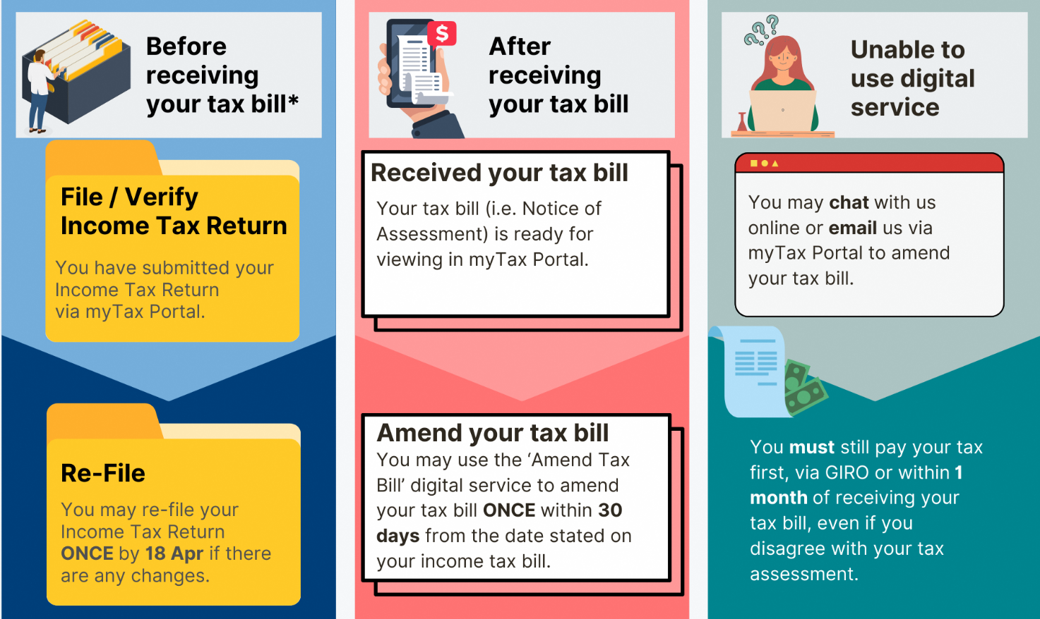

*If you are under the Direct Notice of Assessment (D-NOA) scheme, this is not applicable to you. Refer to Tax Season 2026 - All you need to know for more information on D-NOA.
Obligation to pay taxes
You must still pay the tax first, via GIRO or within 1 month of receiving your tax bill, even if you disagree with your tax assessment.
If you are not paying your taxes via GIRO, a late payment penalty will be imposed for taxes that are outstanding after 1 month. For details, please refer to Penalties for Late or Non-Payment.
We will refund you the credit balance, if any, within 30 days from the date of your new tax bill [i.e. Notice of Assessment (Amended)] if we revise your assessment after reviewing your objection. For details, please refer to Tax Refunds.
Before receiving your tax bill
If you have filed your Income Tax Return online at myTax Portal, you may re-file once by 18 Apr.
Steps to re-file your Income Tax Return:
- Log in to myTax Portal.
- Select "Individuals" > "File Income Tax Return".
- Follow the instructions shown on the screen to re-file.
When you re-file, you must include all your income details, expenses, donations and relief claims, where applicable.
Once you have re-filed successfully, your new submission will override the previous submission.
After receiving your tax bill
Deadline for filing amendments
Your amendments must be filed within 30 days from the date stated in your income tax bill (i.e. Notice of Assessment). IRAS will review your amendments and inform you of the outcome. You may refer to our FAQ (PDF, 286 KB) for more information.
How to file amendments
You may file an amendment using the 'Amend Tax Bill' digital service via myTax Portal for any of the following purposes:
- Revise income declaration;
- Add or amend claims for deductions and reliefs;
- Claim Parenthood Tax Rebate (PTR) (if the PTR account has not been created for your child); or
- Change in tax residency status (from non-resident to resident, if applicable).
Once your amendment has been processed, IRAS will issue your revised tax bill (digital/ paper) within 5 working days. For more complex cases, processing may take up to 2 months. We will notify you via your preferred notification mode when your revised tax bill is finalised or if more information is needed.
FAQs
What if I have overlooked to claim for eligible reliefs (e.g. Qualifying Child Relief) in the previous years?

For assessments raised in 2022 and subsequent years, you have up to 4 years from the end of that relevant year to inform us of your claims. For example, if the assessment was raised in 2022, you have up till 31 Dec 2026 (i.e. 2022 + 4 years) to inform us of your claim.
To claim for eligible reliefs in the preceding years, you may file an amendment using the 'Amend Tax Bill' digital service at myTax Portal.

- Late Filing Penalties
Late filing or non-filing of Individual Income Tax Returns (Form B1/B/P/M)
https://www.iras.gov.sg/taxes/individual-income-tax/basics-of-individual-income-tax/understanding-my-income-tax-filing/late-filing-or-non-filing-of-individual-income-tax-returns-form-b1-b-p-m

The large majority of taxpayers e-file their tax returns by the due date of 18 Apr each year. If you do not file your Individual Income Tax Return on time, you (or the precedent partner in the case of a partnership) will be subject to a composition amount or face recovery actions.
On this page:
- Consequences for late or non-filing of tax returns
- Estimated Notice of Assessment
- Offer of composition
- Court summons
Consequences for late or non-filing of tax returns
Failure to file your Income Tax Return by the due date is an offence.
IRAS may take the following recovery actions if you fail to file by the due date:
- Issue an estimated Notice of Assessment. You must pay the estimated tax within 1 month
- Offer to compound the offence
- Issue a Notice to Attend Court/ Summons
If you receive a letter, form or SMS from IRAS informing you to file an Income Tax Return, you must comply. This requirement applies regardless of your previous year's earnings or whether your employer participates in the Auto-Inclusion Scheme (AIS) for Employment Income.
In the absence of a notification received from IRAS, you can verify whether you need to file an Income Tax Return via our filing checker.
Estimated Notice of Assessment
IRAS may issue an estimated Notice of Assessment based on your income from previous years or other available information. When estimating your tax, IRAS may assume an increase in your income.
If you receive an estimated Notice of Assessment, you must:
- Pay the estimated tax within 1 month from the date of the Notice of Assessment
You must pay the estimated tax even if you intend to object to the assessment or are awaiting the outcome of your objection. Penalties will apply for late payment.
- File your Income Tax Return immediately
You must immediately file your Income Tax Return and/or documents, such as the certified Statement of Accounts, for IRAS to review the estimated tax assessment raised. Any excess tax paid will be refunded.
Offer of composition
Instead of taking prosecution actions, IRAS may offer you (or the precedent partner in the case of a partnership) the option to pay a composition amount.
The composition amount can be up to $5,000 per offence, depending on your past compliance records. A notice will be sent to inform you of the composition amount. To avoid prosecution, you must pay the composition amount and file the overdue tax return and documents by the specified due date.
Paying the composition amount
Quote the payment reference number / payment slip number (for partnerships) when paying the composition amount using the preferred payment modes. GIRO payment is not allowed.
The payment will be processed within 3 working days. To verify if your payment has been credited, log in to myTax Portal and select "View Account Summary".
Legal actions may still be taken against you if you do not file the outstanding tax return and documents after paying the composition amount. The payment made will be used to settle any unpaid tax.
Appealing for waiver of composition amount
Submit your penalty waiver appeal through the Appeal for Penalty Waiver digital service via myTax Portal. You will receive an instant outcome, and successful appeals will be reflected in your tax account within 3 working days.
[Note: To avoid delays, please do not submit appeals through other channels such as myTax Mail, email or calls.]
You will need the following information to complete the appeal for waiver of composition amount request online:
- Year of Assessment
- Contact number
This digital service will take approximately 3-5 minutes to complete.
Appeals will only be considered if:
- You have submitted the outstanding tax returns and/or documents before the due date stated in the offer of composition. The filing, including certified statement of accounts where applicable, must be reflected in your tax account.
- You have filed your tax returns on time for the past 2 years.
Notice to Attend Court/ Summons
A Notice to Attend Court/ Summons may be issued to you (or the precedent partner in the case of a partnership) if IRAS does not receive:
- The required tax return and/or documents by the due date
- Payment of the composition amount by the due date
The notice will specify a court date. To avoid attending court, you must complete all of the following actions by the specified deadline in the Notice to Attend Court/ Summons:
- File the outstanding tax return and/or documents
- Pay the composition amount (Quote the payment slip number)
Postponement of Court hearing
If you need more time to file and/or pay the composition amount, you must attend Court on the specified date indicated in the Notice to Attend Court/ Summons to appeal for a postponement.
Attending Court
Failure to attend Court may result in further legal actions taken against you, potentially including the issuance of a warrant of arrest.
Should you be convicted of the offence in Court, you may face a fine of up to $5,000 for each offence.
You are still required to file the outstanding Income Tax Return and/or documents. Otherwise, further legal actions may be taken.
Failure to file your tax returns for 2 or more years
If you fail to file your tax returns for 2 years or more, you may be issued with a Notice to Attend Court/ Summons. On conviction in Court, for each offence, you may be ordered to pay:
- A penalty that is twice the amount of tax assessed; and
- A fine of up to $5,000.
If you fail to pay the penalty or fine to the Court, you may be imprisoned for up to 6 months.
Filing outstanding tax returns
For current Year of Assessment
e-File your outstanding Income Tax Return via myTax Portal.
If the online tax return is not available, please chat with us or call 1800-356 8300 (+65 6356 8300) to request paper forms to be sent via post.
For previous Year(s) of Assessment
Please chat with us or call 1800-356 8300 (+65 6356 8300) to obtain paper forms via post.
FAQs

I received a notification informing me to file my tax return for the Year of Assessment (YA) but I did not work last year. Do I need to file my tax return?

Although you did not earn any income last year, you are still required to submit your Income Tax Return if you receive a letter, form or an SMS from IRAS informing you to do so.

My employer has sent my employment income details to IRAS. Do I still have to file my tax return?

Although your employer has sent your employment income details to IRAS, you are still required to file your Income Tax Return unless you have received our notification letter or SMS that you are on the No-Filing Service (NFS).
If you received the NFS letter or SMS, you do not need to file an Income Tax Return.

I received a notification to file my Income Tax Return after the filing due date of 18 Apr. When is the due date for filing this return?

If you receive a notification to file your annual Income Tax Return after the filing deadline, you are required to file before the due date stated in the notification.

Can I request an extension to file my overdue tax return?

For current Year of Assessment
Application for an extension of time to file may be made online via our Apply for Extension of Time to File digital service at myTax Portal.
This digital service will take approximately 3-5 minutes to complete and the outcome of your request will be displayed instantaneously.
However, if a Notice to Attend Court/Summons has been issued, filing extensions are not allowed. If you require an extension of time to file, you must attend Court on the specified date indicated in the Notice to Attend Court/ Summons to apply for an extension.
Failure to attend Court may result in further legal actions.
For previous Year(s) of Assessment
No filing extensions will be granted as the returns are long overdue.

- Notices of Assessment
Understanding my tax assessment
"Notice of Assessment" (i.e. tax bill) shows the types and amount of income taxed, deductions claimed, and the amount of tax payable or repayable.
On this page:General income tax glossary
Types of income tax bills
Types of tax billsNotice of Assessment (Original) | Description  This is the tax bill computed based on the tax form(s) that you have submitted and/or information sent by organisations participating in the Auto-Inclusion Scheme.
Types of tax billsNotice of Assessment (Amended) | Description  The Notice of Assessment (Amended) is issued when your assessment is amended downwards resulting in a reduction in tax payable. For example, due to the inclusion of reliefs or reduction in income.  The 'Previous assessment' shows your tax payable from your previous tax bill.
Types of tax billsNotice of Assessment (Additional) | Description  The Notice of Assessment (Additional) is issued when your assessment is amended upwards resulting in additional tax payable. For example, due to the withdrawal of reliefs or inclusion of additional income.  The 'Previous assessment' shows your tax payable from your previous tax bill.
Types of tax billsNotice of Assessment (Estimated) | DescriptionIf you have not filed your Income Tax Return by the due date, we may estimate your tax based on information available and send you Notice of Assessment (Estimated). The estimated tax is shown as 'Estimated Tax Payable'. You must still file your Income Tax Return for us to issue a Notice of Assessment (Amended/Additional).
Tax terms on tax bills
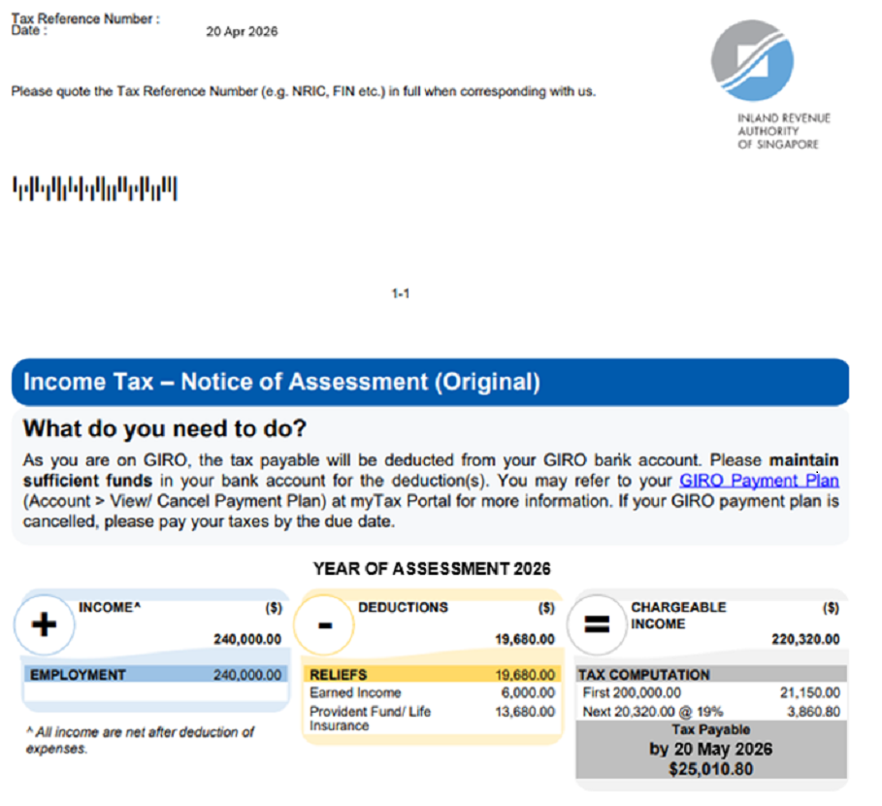
Tax termsYear of Assessment (YA) | ExplanationThis refers to the tax year in which your income tax is calculated and charged. The assessment is for income you have earned in the preceding calendar year. | ExampleIncome taxed in YA 2026, refers to income earned from 1 Jan 2025 to 31 Dec 2025.
Tax termsIncome | ExplanationThe amount reflected under 'Income' is your total income after deducting allowable expenses.  The total income includes:  - employment income;  - trade income for the accounting year; and/or  - other income such as rental income. | Example  - 'Employment' income shown is the net amount after deducting your employment expenses.  - 'Rental' income shown is the net amount after deducting your rental expenses.  - 'Trade' income shown is the net amount after deducting your allowable business expenses.
Tax termsDeductions | ExplanationDeductions like donations and reliefs can help lower your income subject to tax. | Example
Tax termsChargeable income | ExplanationThis refers to your 'Income', after subtracting 'Deductions'. | Example
Tax termsTax payable | ExplanationThis refers to the amount of tax that you need to pay. | Example'Tax payable by 20 May 2026 $25,010.80' means you must pay $25,010.80 to IRAS by 20 May 2026, unless you are paying your taxes via GIRO.
Tax termsTax repayable/discharged | ExplanationThis refers to the amount of tax that will be refunded to you. | Example'Tax repayable/discharged $300' means $300 will be refunded to you.
General income tax glossary
Tax termsBasis period | ExplanationThis refers to the period of income relevant to the YA. The basis period for a YA is the year preceding that YA.  The basis period for YA 2026 is 1 Jan 2025 to 31 Dec 2025.  If you receive business income, the basis period may be different if your accounts are made up to a date other than 31 Dec. | ExampleExample 1: Employment income  Mr Tan has employment income from 1 Jan 2025 to 31 Dec 2025. This income is earned in the basis period from 1 Jan 2025 to 31 Dec 2025 and hence, it will be assessed in the YA 2026.  Example 2: Business income  Mr Lee is a sole-proprietor. His business financial year ends on 31 Mar 2025. His business income is earned in the basis period from 1 Apr 2024 to 31 Mar 2025 and hence, it will be assessed in the YA 2026.
Tax termsAssessable income | ExplanationThis is your total income after deducting allowable expenses and approved donations.  Total income includes:  - employment income;  - trade income for the accounting year; and/or  - other income such as rental income.  Note: Chargeable income is the remainder of your assessable income after deducting personal reliefs. | ExampleMr Lim has:  Employment income = $50,000  Allowable expenses and donations = $5,000  Assessable income = $50,000 - $5,000 = $45,000  Personal reliefs = $10,000  Chargeable income = $45,000 - $10,000 = $35,000
Tax termsPersonal reliefs | ExplanationThere are deductions which can help you save tax.  These are allowable if:  - You are a Singapore tax resident; and  - You meet the qualifying conditions. | Example

